1. 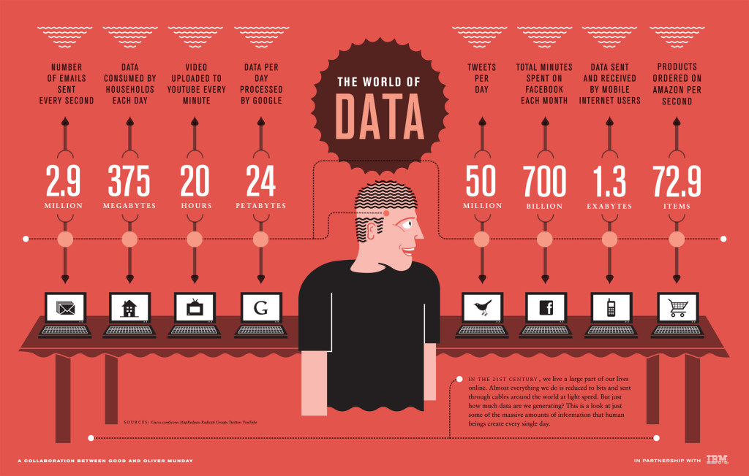Find a visualization online and answer the following questions pertaining to that visualization. Attach the visualization as a screenshot in your submission.
2. Consider Bertin’s characterization of visual variables (position, size, shape, value, color, orientation, and texture). Pick 2 of Bertin’s visual variables, and discuss them in relation to your visualization.

Position: The Position of the computers in the visualization above does not create a specific order in the data. In this case the data is just randomly placed. The position does not really indicate anything.

Size: In this visualization everything has an equal size no matter how big the data number is. A change in size or length would normally indicate the quantity of the data. In this case it isn’t.

1. Do you agree that visualization is a functional art? Explain.

I agree that visualization is a functional art. When you’re visualization data you’re free to use your artistic side and create a piece of art. When you add data to your visualization you make it a piece of art that is very functional for other people.

1. Ask yourself what the designer is trying to convey and think of three to four possible tasks this visualization should help you with. Does the visualization achieve any of your tasks? (To view an example, see Albert Cairo, pages 26-­28.)

Task 1: I want to get an indication of the amount of data that is processed over the world.

Task 2: I want to know what kind of data people send the most.

Task 3: I want to know how many data Google processes per day.

Does the visualization achieve any of your tasks?

Yes task 2 does, it shows the amount of data that Google processes per day. Task 1 can also be achieved but it only gives a selected indication.